# Leeming Senior High School

### Year 11 Examination, 2015

### Question/Answer Booklet

**SOLUTIONS**

# MATHEMATICS

# SPECIALIST

# UNITS 1 AND 2

## Section One:

## Calculator-free

|  |  |  |  |  |  |  |  |  |
| --- | --- | --- | --- | --- | --- | --- | --- | --- |
| Student Number: In figures |  |  |  |  |  |  |  |  |

In words

Your name

## Time allowed for this section

Reading time before commencing work: five minutes

Working time for this section: fifty minutes

## Materials required/recommended for this section

##### *To be provided by the supervisor*

This Question/Answer Booklet

Formula Sheet

##### *To be provided by the candidate*

Standard items: pens (blue/black preferred), pencils (including coloured), sharpener,

correction fluid/tape, eraser, ruler, highlighters

Special items: nil

## Important note to candidates

No other items may be taken into the examination room. It is **your** responsibility to ensure that you do not have any unauthorised notes or other items of a non-personal nature in the examination room. If you have any unauthorised material with you, hand it to the supervisor **before** reading any further.

## Structure of this paper

|  |  |  |  |  |  |
| --- | --- | --- | --- | --- | --- |
| Section | Number of questions available | Number of questions to be answered | Working time (minutes) | Marks available | Percentage of exam |
| Section One:  Calculator-free | 8 | 8 | 50 | 52 | 35 |
| Section Two:  Calculator-assumed | 13 | 13 | 100 | 98 | 65 |
|  | | | **Total** | 150 | 100 |

## Instructions to candidates

1. The rules for the conduct of examinations are detailed in the school handbook. Sitting this examination implies that you agree to abide by these rules.
2. Write your answers in this Question/Answer Booklet.
3. You must be careful to confine your response to the specific question asked and to follow any instructions that are specified to a particular question.
4. Spare pages are included at the end of this booklet. They can be used for planning your responses and/or as additional space if required to continue an answer.

* Planning: If you use the spare pages for planning, indicate this clearly at the top of the page.
* Continuing an answer: If you need to use the space to continue an answer, indicate in the original answer space where the answer is continued, i.e. give the page number. Fill in the number of the question that you are continuing to answer at the top of the page.

1. **Show all your working clearly**. Your working should be in sufficient detail to allow your answers to be checked readily and for marks to be awarded for reasoning. Incorrect answers given without supporting reasoning cannot be allocated any marks. For any question or part question worth more than two marks, valid working or justification is required to receive full marks. If you repeat any question, ensure that you cancel the answer you do not wish to have marked.
2. It is recommended that you **do not use pencil**, except in diagrams.
3. The Formula Sheet is **not** to be handed in with your Question/Answer Booklet.

Section One: Calculator-free (52 Marks)

This section has**eight (****8)** questions. Answer **all** questions. Write your answers in the spaces provided.

Working time for this section is 50 minutes.

Question 1 (5 marks)

(a) If $\tan{A=\frac{1}{2}}$, determine the exact value of $\tan{2A}$. (2 marks)



(b) Solve $\cos\left(2\left(x-10°\right)\right)=0.5$, $0°≤x≤180°$. (3 marks)



Question 2 (6 marks)

If , state whether the following are true or false. If false, clearly explain your reasoning.

(a) . (1 mark)

False – cannot add different size matrices.

(b) . (1 mark)

True.

(c) . (1 mark)

False, as  and  do not exist.

(d) . (1 mark)

False, result is the matrix [13].

(e) . (1 mark)

True.

(f) . (1 mark)

False, matrix C must be square to have an inverse.

Question 3 (7 marks)

Two vectors are given by  and . Determine

(a) a vector parallel to $a-b$ of magnitude 25. (3 marks)



(b) a in terms of d and e, where  and . (4 marks)



Question 4 (8 marks)

(a) Evaluate . (1 mark)



(b) Determine the number of different permutations of the letters in the word NEEDLED.

(2 marks)



(c) A password is formed using all seven of the characters $, %, @, Y, Z, 8 and 9 just once. Determine the number of different passwords that are possible in which all the symbols are adjacent, all the letters are adjacent and all the digits are adjacent. (3 marks)



(d) Determine the least number of randomly chosen integers between 10 and 99 required to be certain that the difference of the digits in at least two of the integers is the same. (*For example, the difference of the digits in the integer *). (2 marks)

There are 10 possible differences (from 0 to 9), which give us 10 pigeonholes to fill.

If more than 10 numbers are chosen, then at least one pigeonhole must contain two or more numbers. So at least 11 numbers must be chosen.

Question 5 (5 marks)

A proposition states that for any integer *n*, if  is even, then *n* is odd.

(a) Write the contrapositive of this proposition. (1 mark)

If *n* is not odd, then  is not even.

(b) Use the contrapositive statement to prove the proposition is true. (4 marks)

If *n* is not odd:



Hence, as the contrapositive has been shown to be true, the original proposition must also be true.

Question 6 (7 marks)

(a) Sketch the graph of $y=2\operatorname{cosec}{(x+90)}$ for . (3 marks)

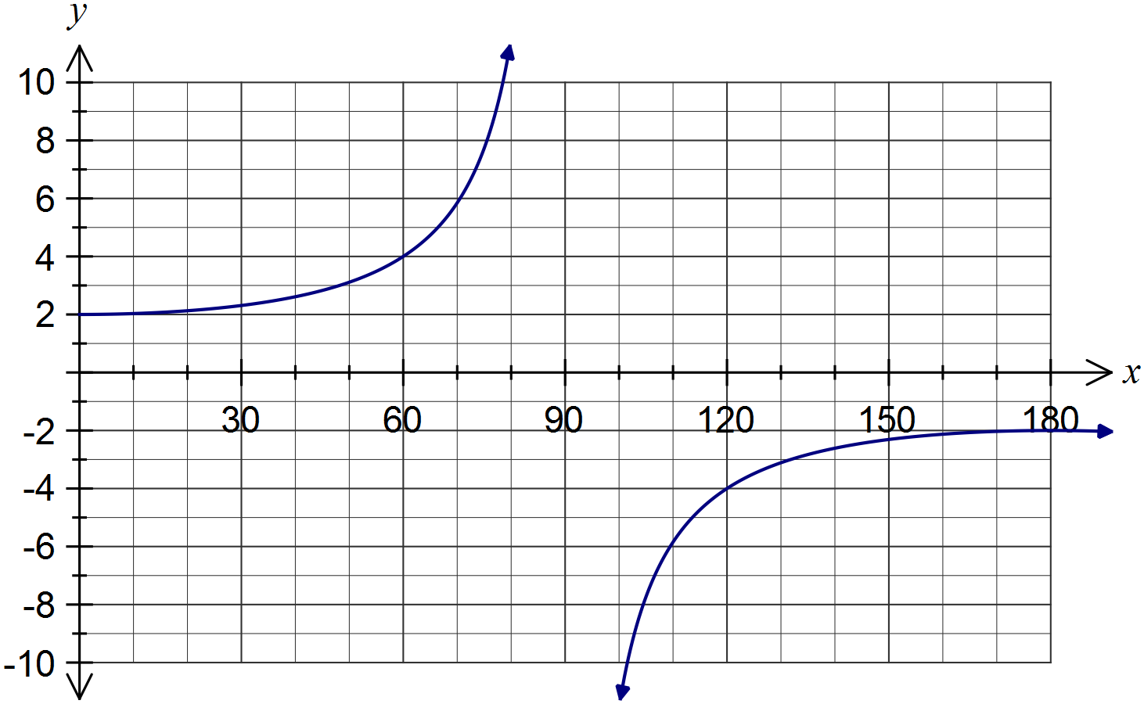

(b) Prove the identity $\cot{A+\tan{A=\sec{A}\operatorname{cosec}{A}}}$. (4 marks)



Question 7 (7 marks)

(a) Matrix *A* represents a rotation of 180º about the origin. Determine

(i) matrix *A*. (1 mark)



(ii) the exact coordinates of the point (-2, 3) after transformation by matrix *A*. (1 mark)



(iii) the determinant of matrix *A*. (1 mark)

1

(b) Matrix . Describe the transformation represented by *B* and calculate its determinant. (2 marks)

*B* is a reflection in the *y*-axis.

$$\det\left(B\right)=-1$$

(c) Use an example to show that two non-singular square matrices $C$ and $D$ exist such that the determinant of their sum is equal to the sum of their determinants. (2 marks)



Question 8 (7 marks)

The complex number , where  is a real constant.

(a) Show that  and that . (4 marks)



(b) Determine the value(s) of  when . (3 marks)



Additional working space

Question number: _________

This examination paper may be freely copied, or communicated on an intranet, for non-commercial purposes within educational institutes that have purchased the paper from WA Examination Papers provided that WA Examination Papers is acknowledged as the copyright owner. Teachers within Leeming Senior High School may change the paper provided that WA Examination Paper's moral rights are not infringed.

Copying or communication for any other purposes can only be done within the terms of the Copyright Act or with prior written permission of WA Examination papers.

*Published by WA Examination Papers*

*PO Box 445 Claremont WA 6910*